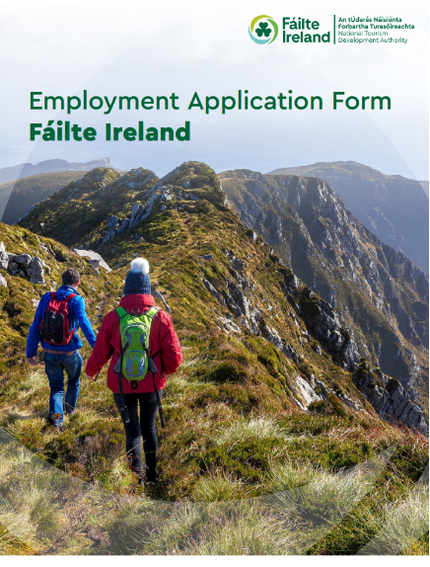

Employment Application Form
Position Applied For:
Destination Development Manager
Preferred Location  (Please select up to a maximum of 2 locations) | Mark with (X)
4th Floor, Mathew House, Fr. Mathew St., Cork, T12TN56 | [ ]
Áras Fáilte, 88-95 Amiens Street, Dublin 1, D01 WR86 | [ ]
​1st floor, Market House, Pearse Street, Mullingar, N91 PW95 | [ ]
Closing Date for Application:
21st October 2026 at 3pm.

LATE APPLICATIONS WILL NOT BE CONSIDERED I.E. RECEIVED AFTER 3.00PM (IRELAND TIME)
We will contact you either by email or by telephone.
Please answer all the following questions:

• Please answer the questions fully as this will enable us to correctly assess your application.
• Only the application form will be used for screening purposes.
• Please type your responses - do not handwrite.

Use of AI tools: Please note applications are reviewed by the recruitment team, hiring manager and/or a panel and are not screened using AI. To help us assess your experience fairly, please complete your application in your own words and do not use AI assistance to generate responses.

PERSONAL DETAILS

First Name: | Surname:
Email: | Telephone No:
Are you currently employed by Fáilte Ireland? | ☐ Yes ☐ No
Please note that we require prior confirmation of your eligibility to work in the Republic of Ireland. Please select which applies | ☐ I am a citizen of the European Economic Area (EEA)  ☐ I am a citizen of the United Kingdom  ☐ I am a citizen of Switzerland pursuant to the agreement between the EU and Switzerland on the free movement of persons  ☐ I hold a valid work authorisation / permit (please refer to question 2)  ☐ I do not hold a valid work authorisation / permit and am not eligible to work in Republic of Ireland  Please provide details of your valid work permit if applicable.
Please indicate if you are proficient in the Irish Language | ☐ Yes ☐ No
If yes, please select from these options to indicate your level of knowledge of the Irish Language.  We collect information on Irish language proficiency to support compliance with the Official Languages Act 2021 and to understand the Irish language capability of our workforce. This information is used for monitoring and reporting purposes only and will not affect your application unless Irish language skills are expressly required for the role | ☐ Level 1 - I have little or no knowledge of the Irish Language (e.g. I did not learn Irish in School)  ☐ Level 2 - I am able to communicate at a very basic level on Irish (e.g. I can talk about my background, where I live etc.)  ☐ Level 3- I have studied Irish at school and understand a good deal of the language but have had few opportunities to use in recent years  ☐ Level 4 - I am comfortable speaking Irish and use the language from time to time  ☐ Level 5 - I am fluent in Irish
Do you require reasonable accommodation to be made at any stage of the selection process?  At Fáilte Ireland, we’re committed to fostering an inclusive workplace where diversity is valued and everyone is treated fairly and respectfully. This applies to everyone regardless of gender, civil status, family status, sexual orientation, age, disability, race, religion or membership of the Traveller community. | ☐ Yes ☐ No ☐ Do not wish to disclose
By ticking yes to reasonable accommodation, you are giving consent for Fáilte Ireland to contact you to discuss the requirements and make the necessary arrangements. Eligibility to work will be verified. Irish-language information will only be used in relation to the Official Languages (Amendment) Act 2021.
Where did you hear about this vacancy? | ☐ Fáilte Ireland Website  ☐ PublicJobs.ie  ☐ Open Doors Initiative  ☐ LinkedIn  ☐ Conscia Talent  ☐ Word of Mouth  ☐ Other  If Other, please give details:

Employment Application Form
QUALIFICATION DETAILS

Please list colleges/universities/professional bodies attended and qualifications obtained, together with any relevant training/development courses.
College/University/Professional Bodies | Course Name | Qualification Type / Level | Duration of Course  (in years)
PROFESSIONAL BODIES & OTHER TRAINING COURSES

Please list any relevant training/development courses attended with dates.

Employment Application Form
EMPLOYMENT HISTORY

Name of employer: | Nature of business:
Job title: | Start date: End date:
Roles and Responsibilities:
Reason for leaving:

Name of employer: | Nature of business:
Job title: | Start date: End date:
Roles and Responsibilities:
Reason for leaving:

Employment Application Form
EMPLOYMENT HISTORY

Name of employer: | Nature of business:
Job title: | Start date: End date:
Roles and Responsibilities:
Reason for leaving:

Name of employer: | Nature of business:
Job title: | Start date: End date:
Roles and Responsibilities:
Reason for leaving:

Employment Application Form
EMPLOYMENT HISTORY

Name of employer: | Nature of business:
Job title: | Start date: End date:
Roles and Responsibilities:
Reason for leaving:

Name of employer: | Nature of business:
Job title: | Start date: End date:
Roles and Responsibilities:
Reason for leaving:

Employment Application Form
KEY COMPETENCIES - Candidate must provide evidence of the following:

Vacancy Specific & Competency Questions (Please note there is a max of 350 words per question – anything above not being recorded after submission).
Please give your reasons for making this application, relating your experience, achievements and abilities to the post for which you are applying. Make any points of particular interest, such as practical experience in specialised areas and notable achievements.
Are you proficient in the use of Microsoft Office applications (e.g. Outlook, Word, Excel, PowerPoint, and Teams) required to perform the duties of this role?

☐ Yes ☐ No

Inspire and Engage:
Describe a specific example of how you led, motivated and developed a team to deliver a complex programme or significant change. Explain how you set clear expectations, built accountability and collaboration, supported team capability and wellbeing, and achieved measurable outcomes relevant to the objectives of this role.

Please give one specific example of where you demonstrated strong skills in this area (max 350 words - anything above may disqualify).

Managing Relationships:
Provide an example of when you used strong interpersonal and influencing skills to gain the support of senior leaders, colleagues and/or external stakeholders for a new approach, standard or way of working. Outline the differing perspectives involved, how you co-designed or communicated the approach, how you addressed resistance, and the outcome achieved.
Please give one specific example of where you demonstrated strong skills in this area (max 350 words - anything above may disqualify).

Project Management:
Describe a complex programme or portfolio that you managed from planning through to delivery and review. Explain how you established governance, prioritised resources, managed procurement or budgets where relevant, tracked milestones, KPIs, risks and dependencies, maintained reliable reporting, and ensured delivery against agreed objectives.
Please give one specific example of where you demonstrated strong skills in this area (max 350 words - anything above may disqualify).

Embracing Innovation:
Give an example of how you identified, assessed and embedded best-practice methodology to improve a process, service or programme. Describe how you drew on evidence or national/international learning, translated it into practical tools or ways of working, influenced others to adopt it, and measured whether the improvement was sustained.
Please give one specific example of where you demonstrated strong skills in this area (max 350 words - anything above may disqualify).
Fáilte Ireland is an equal opportunities employer and is committed to fostering an inclusive workplace which values and benefits from the diversity of the workforce. We encourage you to reach out directly at recruitment@failteireland.ie should you require assistance or reasonable accommodation during the recruitment process.
DECLARATION

I declare that by submitting this application form, the foregoing particulars are complete and correct to the best of my knowledge and belief, and I consent to my personal details being used to process my employment application.
Any candidate found to have knowingly given false information, or to have will fully suppressed any material fact will be liable to disqualification, or if appointed, to dismissal.
Signature: | Date:

