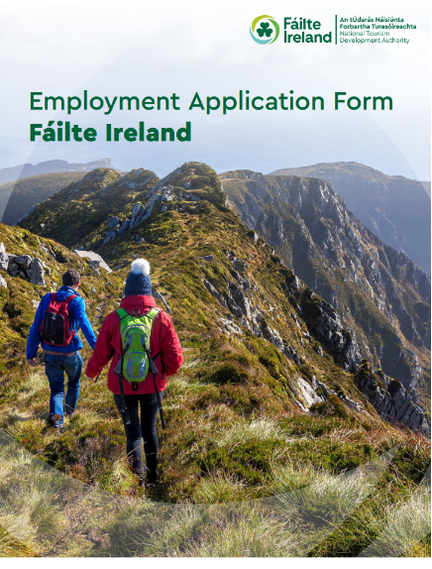

Employment Application Form
Position Applied For:
Manager, Corporate Communications and Public Affairs – Internal Communications (Temporary, Full-time)
Location
Áras Fáilte, 88-95 Amiens Street, Dublin 1, D01 WR86
Closing Date for Application:
18th November 2026 at 3pm.

LATE APPLICATIONS WILL NOT BE CONSIDERED I.E. RECEIVED AFTER 3.00PM (IRELAND TIME)
We will contact you either by email or by telephone.
Please answer all the following questions:

• Please answer the questions fully as this will enable us to correctly assess your application.
• Only the application form will be used for screening purposes.
• Please type your responses - do not handwrite.

Use of AI tools: Please note applications are reviewed by the recruitment team, hiring manager and/or a panel and are not screened using AI. To help us assess your experience fairly, please complete your application in your own words and do not use AI assistance to generate responses.

PERSONAL DETAILS

First Name: | Surname:
Email: | Telephone No:
Are you currently employed by Fáilte Ireland? | ☐ Yes ☐ No
Please note that we require prior confirmation of your eligibility to work in the Republic of Ireland. Please select which applies | ☐ I am a citizen of the European Economic Area (EEA)  ☐ I am a citizen of the United Kingdom  ☐ I am a citizen of Switzerland pursuant to the agreement between the EU and Switzerland on the free movement of persons  ☐ I hold a valid work authorisation / permit (please refer to question 2)  ☐ I do not hold a valid work authorisation / permit and am not eligible to work in Republic of Ireland  Please provide details of your valid work permit if applicable.
Please indicate if you are proficient in the Irish Language | ☐ Yes ☐ No
If yes, please select from these options to indicate your level of knowledge of the Irish Language.  We collect information on Irish language proficiency to support compliance with the Official Languages Act 2021 and to understand the Irish language capability of our workforce. This information is used for monitoring and reporting purposes only and will not affect your application unless Irish language skills are expressly required for the role | ☐ Level 1 - I have little or no knowledge of the Irish Language (e.g. I did not learn Irish in School)  ☐ Level 2 - I am able to communicate at a very basic level on Irish (e.g. I can talk about my background, where I live etc.)  ☐ Level 3- I have studied Irish at school and understand a good deal of the language but have had few opportunities to use in recent years  ☐ Level 4 - I am comfortable speaking Irish and use the language from time to time  ☐ Level 5 - I am fluent in Irish
Access to own means of transport/ Valid driving licence. | ☐ Yes ☐ No
Do you require reasonable accommodation to be made at any stage of the selection process?  At Fáilte Ireland, we’re committed to fostering an inclusive workplace where diversity is valued and everyone is treated fairly and respectfully. This applies to everyone regardless of gender, civil status, family status, sexual orientation, age, disability, race, religion or membership of the Traveller community. | ☐ Yes ☐ No ☐ Do not wish to disclose
By ticking yes to reasonable accommodation, you are giving consent for Fáilte Ireland to contact you to discuss the requirements and make the necessary arrangements. Eligibility to work will be verified. Irish-language information will only be used in relation to the Official Languages (Amendment) Act 2021.
Where did you hear about this vacancy? | ☐ Fáilte Ireland Website  ☐ PublicJobs.ie  ☐ Open Doors Initiative  ☐ LinkedIn  ☐ Conscia Talent  ☐ Word of Mouth  ☐ Other  If Other, please give details:

Employment Application Form
QUALIFICATION DETAILS

Please list colleges/universities/professional bodies attended and qualifications obtained, together with any relevant training/development courses.
College/University/Professional Bodies | Course Name | Qualification Type | Level | Duration of Course  (in years)
PROFESSIONAL BODIES & OTHER TRAINING COURSES

Please list any relevant training/development courses attended with dates.

Employment Application Form
EMPLOYMENT HISTORY

Name of employer: | Nature of business:
Job title: | Start date: End date:
Roles and Responsibilities:
Reason for leaving:

Name of employer: | Nature of business:
Job title: | Start date: End date:
Roles and Responsibilities:
Reason for leaving:

Employment Application Form
EMPLOYMENT HISTORY

Name of employer: | Nature of business:
Job title: | Start date: End date:
Roles and Responsibilities:
Reason for leaving:

Name of employer: | Nature of business:
Job title: | Start date: End date:
Roles and Responsibilities:
Reason for leaving:

Employment Application Form
EMPLOYMENT HISTORY

Name of employer: | Nature of business:
Job title: | Start date: End date:
Roles and Responsibilities:
Reason for leaving:

Name of employer: | Nature of business:
Job title: | Start date: End date:
Roles and Responsibilities:
Reason for leaving:

Employment Application Form
KEY COMPETENCIES - Candidate must provide evidence of the following:

Vacancy Specific & Competency Questions (Please note there is a max of 350 words per question – anything above not being recorded after submission).
Please give your reasons for making this application, relating your experience, achievements and abilities to the post for which you are applying. Make any points of particular interest, such as practical experience in specialised areas and notable achievements.
Are you proficient in the use of Microsoft Office applications (e.g. Outlook, Word, Excel, PowerPoint, and Teams) required to perform the duties of this role?

☐ Yes ☐ No

Strategic Thinking: Describe an example of how you developed an internal communications strategy or campaign to support organisational priorities in a complex organisation. Explain how you identified communication needs, used insight or feedback to shape your approach, and measured the impact.

Please give one specific example of where you demonstrated strong skills in this area (max 350 words - anything above may disqualify).

Managing Relationships: Describe an example of how you built and managed relationships with senior leaders and colleagues across different functions to deliver an internal communications initiative. Explain how you influenced decisions, addressed differing priorities and secured collaboration, and outline the outcome.
Please give one specific example of where you demonstrated strong skills in this area (max 350 words - anything above may disqualify).

Communicating Effectively: Describe an example of how you translated complex organisational information into clear and engaging internal communications. Explain how you developed and edited the messaging, tailored the content and channels to your audience, and used digital tools to support delivery. How did you establish whether the communications were effective?
Please give one specific example of where you demonstrated strong skills in this area (max 350 words - anything above may disqualify).

Project Management: Describe an internal communications project, campaign or staff event that you managed from planning through to delivery. Explain how you organised the work, coordinated team members and any external providers, managed timelines and resources, and responded to competing priorities. Outline the results achieved and how you evaluated success.
Please give one specific example of where you demonstrated strong skills in this area (max 350 words - anything above may disqualify).
Fáilte Ireland is an equal opportunities employer and is committed to fostering an inclusive workplace which values and benefits from the diversity of the workforce. We encourage you to reach out directly at recruitment@failteireland.ie should you require assistance or reasonable accommodation during the recruitment process.
DECLARATION

I declare that by submitting this application form, the foregoing particulars are complete and correct to the best of my knowledge and belief, and I consent to my personal details being used to process my employment application.
Any candidate found to have knowingly given false information, or to have will fully suppressed any material fact will be liable to disqualification, or if appointed, to dismissal.
Signature: | Date:

